CS 255 Project Two — DriverPass System Design Document

UML Diagrams

UML Use Case Diagram
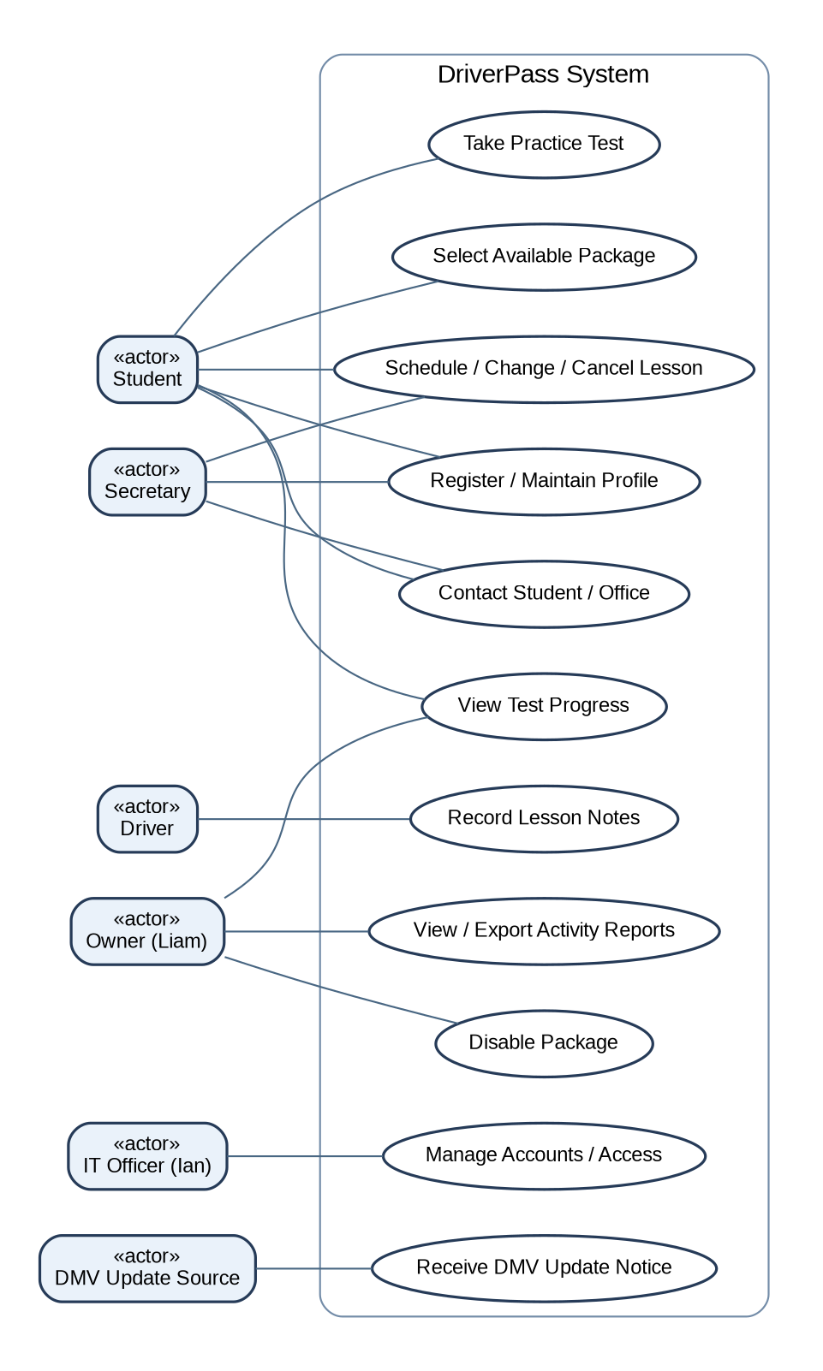
Figure 1. System users and their permitted DriverPass functions. The DMV update source is external; training content is reviewed before publication.

UML Activity Diagrams
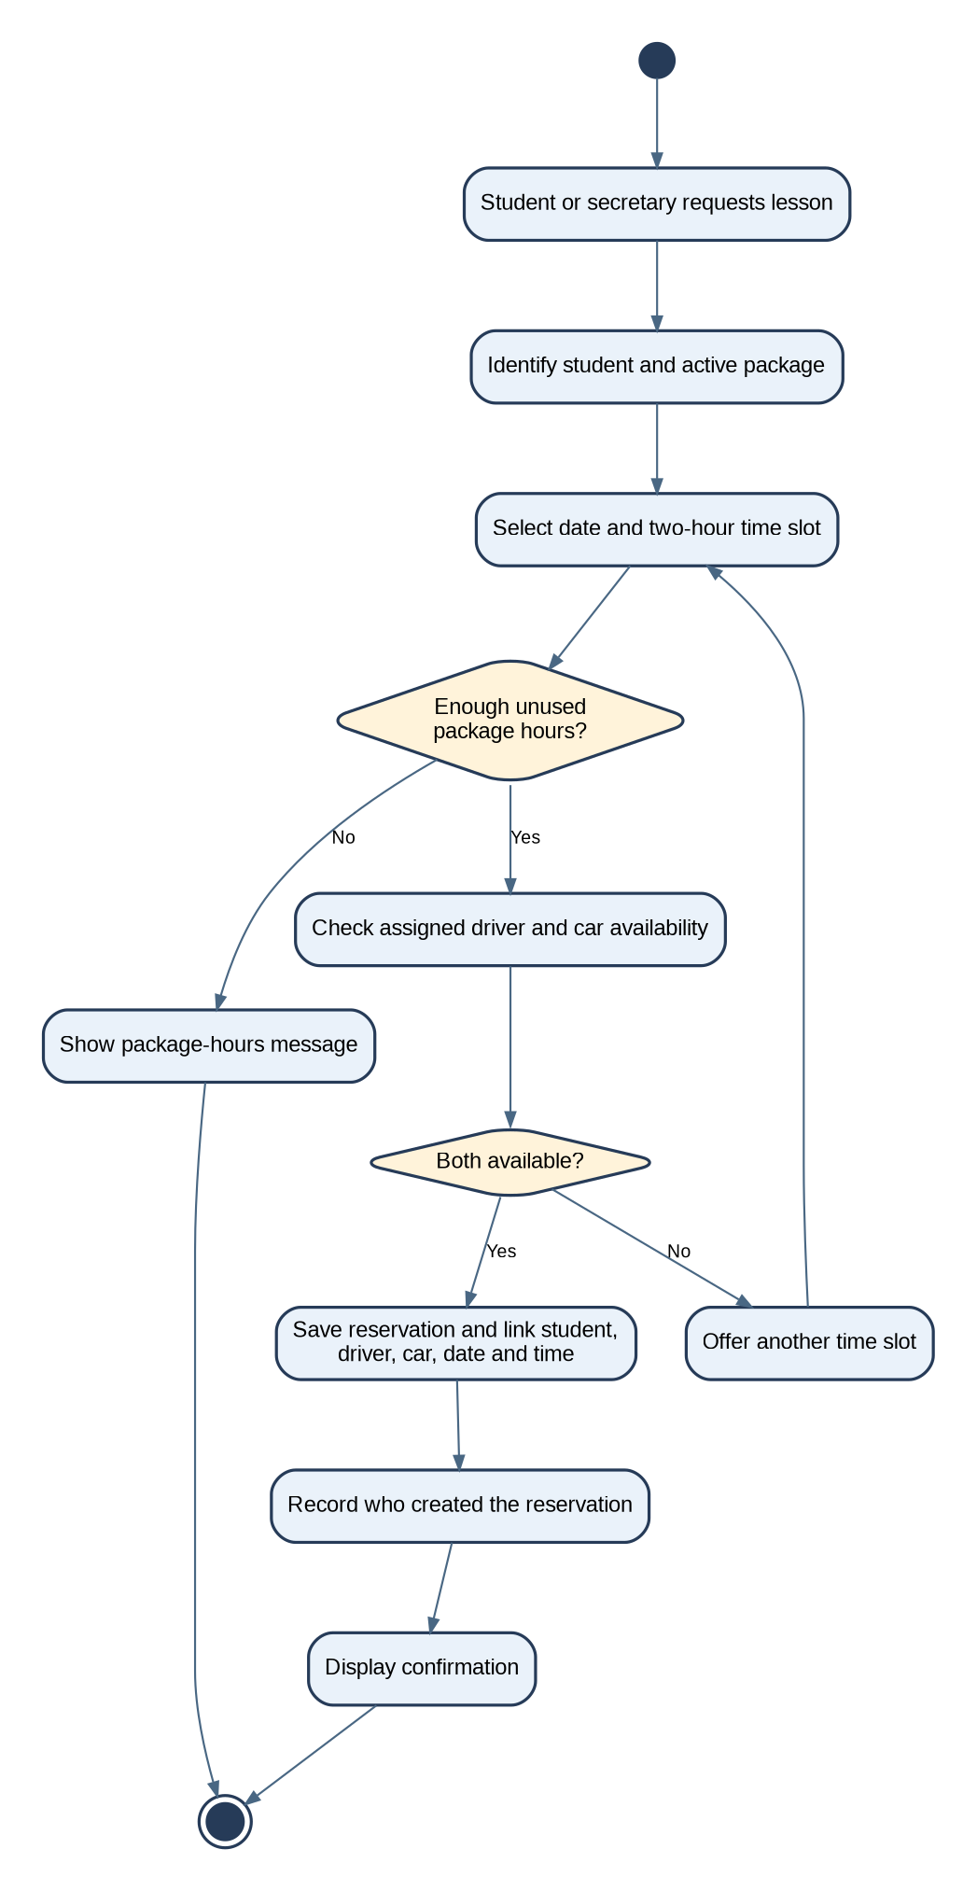
Figure 2. Scheduling a two-hour lesson, including package-hour validation, resource checks, and a recorded change history.
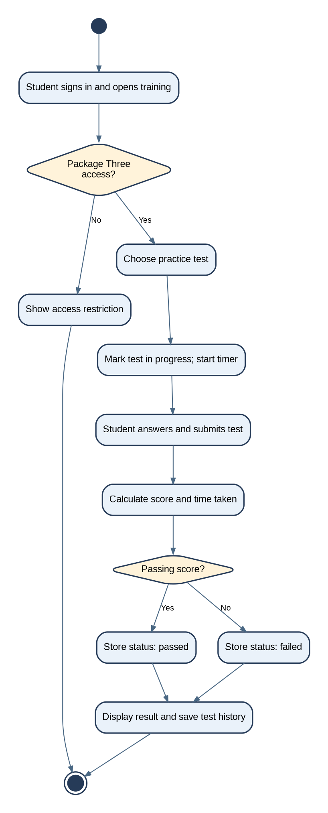
Figure 3. Completing a practice test. Online testing is limited to Package Three; results preserve time, score, and status.

UML Sequence Diagram
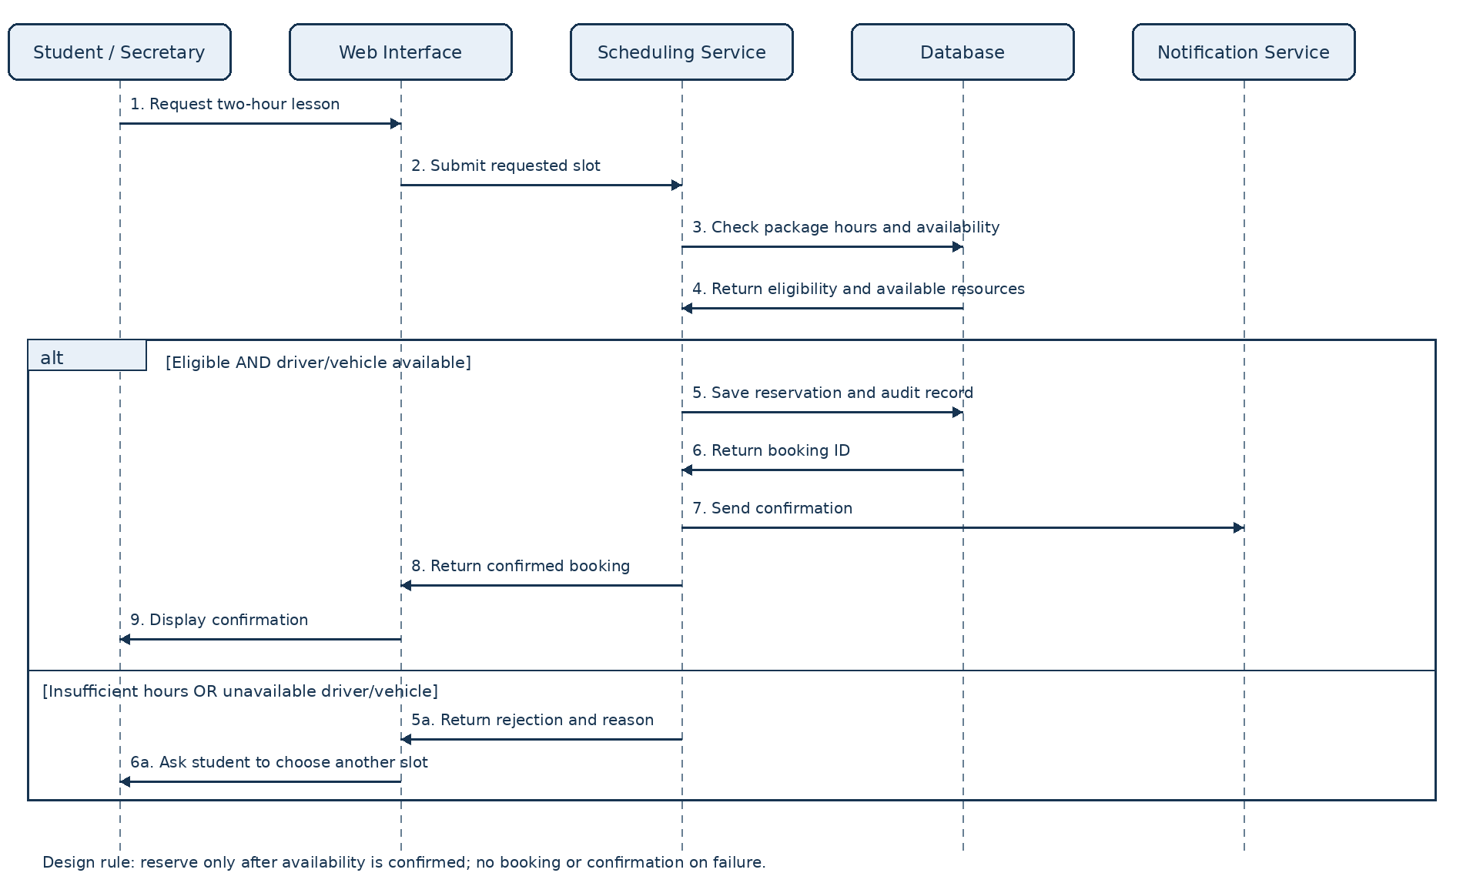
Figure 4. Scheduling message sequence. The service checks eligibility and availability before saving the reservation and audit record.

UML Class Diagram
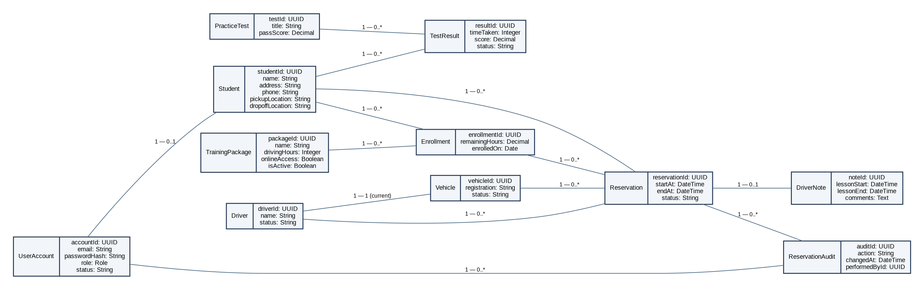
Figure 5. Proposed class structure. Relationship labels show multiplicities; the model separates package definitions from student enrollments and reservations.

Technical Requirements

Hardware and access
Students and staff need internet-connected computers, tablets, or smartphones with current browsers. Drivers need a supported connected device to enter lesson times and notes. DriverPass does not need an on-premises server; a cloud hosting provider supplies compute, storage, and backup infrastructure.

Application software and interface
Build a responsive browser-based application with separate student, secretary, driver, owner, and IT administration views. Student screens support registration, package selection, scheduling, progress, and password resets. Secretary screens support customer intake and appointment changes. Drivers enter lesson times and notes. Owner screens show activity, progress, and exportable reports; the IT officer manages account access.

Database and scheduling logic
Use a managed relational database for accounts, students, training packages, enrollments, vehicles, drivers, reservations, test results, driver notes, and reservation audits. Each booking links a student, enrolled package, driver, vehicle, start and end time. The scheduling service enforces two-hour sessions, remaining package hours, same pickup/drop-off location, and prevention of overlapping vehicle or driver assignments. Save reservations and audit records in one transaction to prevent incomplete or duplicated changes.

Security and payment handling
Require individual accounts, strong password hashing, encrypted HTTPS connections, role-based authorization, secure password reset, login-rate limiting, and audit records of who created, changed, or canceled a reservation. Encrypt sensitive stored data and restrict staff access. Use a PCI-compliant payment provider to tokenize card information; never retain card security codes after authorization. Exact provider selection and payment workflow require client approval.

Cloud infrastructure, resilience, and reporting
Deploy the web application and database in managed cloud services with automated encrypted backups, recovery testing, monitoring, and access logs. Maintain separate development, testing, and production environments. Export authorized activity and progress reports to printable formats or CSV/Excel-compatible files. Offline copies are read-only snapshots; users must reconnect to update live data.

DMV updates and training content
Provide a monitored import or notification process for DMV rule, policy, and sample-question changes. Alert authorized staff to review changes before updating student-facing content. The interview does not specify a DMV interface or feed; any API, file import, or manual-review mechanism is a proposed implementation pending verification.

Design tools, testing, and limits
The five UML diagrams were prepared using diagramming tools and are included in this design document. Use version control, automated tests, browser testing, and accessibility checks during implementation. Test concurrent booking attempts, package-hour limits, role restrictions, test-status transitions, backups, and export permissions. Initial scope allows disabling packages but not self-service creation/removal of package modules. Performance targets, cloud vendor, and supported browser versions remain to be agreed with DriverPass.

